 Sample Design Work: GroupBuild

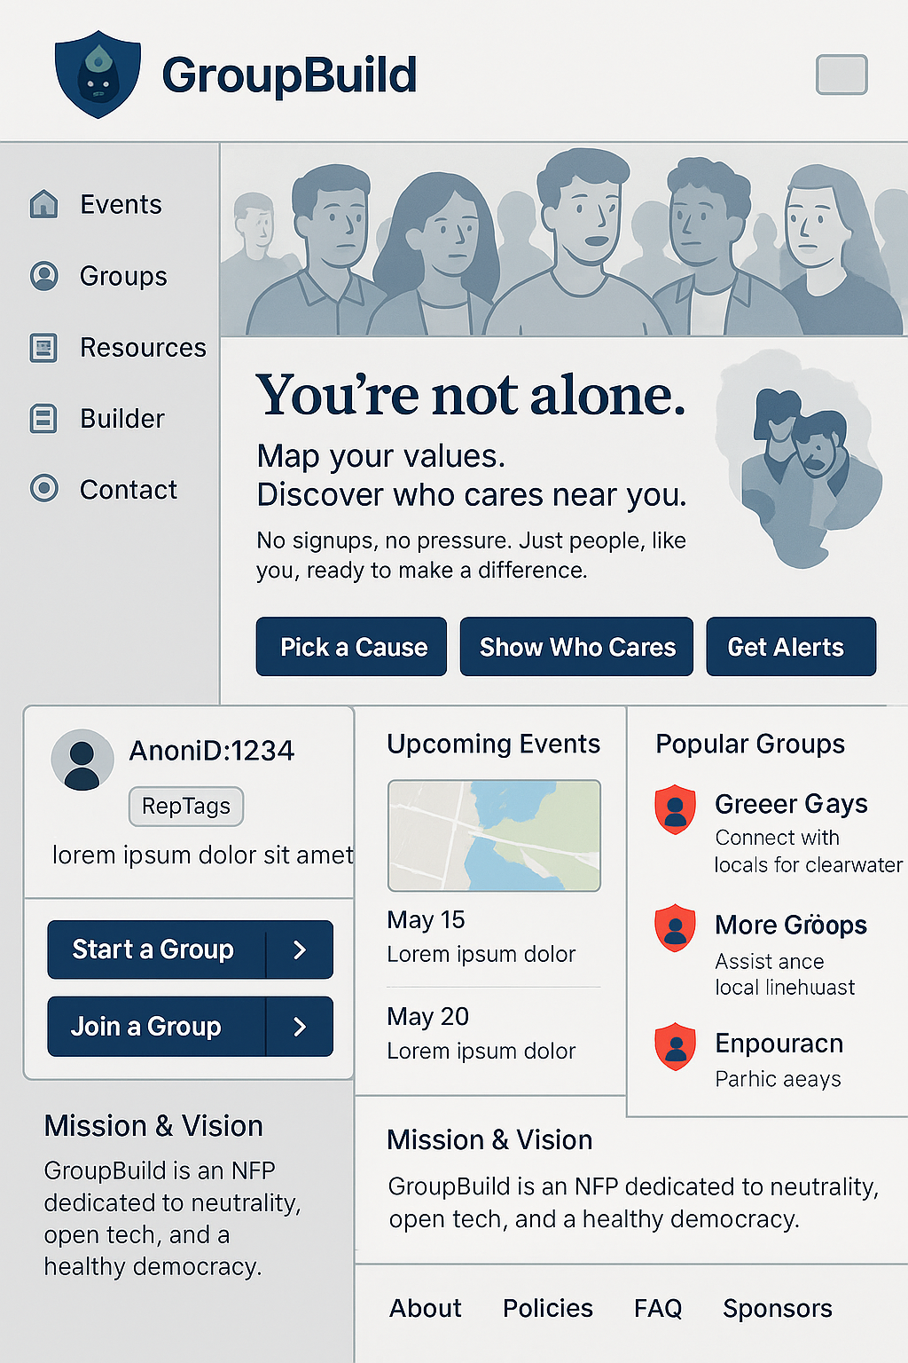
0. [This document is a sample]
This document is designed to illustrate the planning discussions currently underway via the GroupBuild Discord server.
For further information contact: Rick Ballard | +1.416.414.8100 | rick@GroupBuild.org | Bio and Publications

1. [First-Impression UX Strategy]
- Navigation panel shows:
- Site is hyper-active (drop-down list of most active Groups, event map thumbnails)
- Most content accessible without Anon-ID registration
- Header sections show:
- Values alignment via a graphic showing protestor faces
- Tagline to validate emotional resonance with dissenters
- Explainer video auto-cycles over graphic after 10 seconds
- Users behave; BeAxa thumbnail animation links to explainer on AI moderation (BeAxa), ScriptTag and RepTag systems that help deprioritize toxicity without censorship
- Mid sections show:
- Call-to-Actions direct users via Anon-ID registration: [Explore Groups], [Join A Cause], [Start A Movement], [Find Your People], [Stay Safe]
- Default map region shows North America, with Washington DC as an overlay thumbnail
- Auto-cycling banner shows example Groups (use fake profiles in demo)
- Footer Section shows:
- Trust-building links: vision, values, policies, FAQs (5W’s)
- Organization model: governance, staff-ownership, encrypted messaging

2. [Layout Overview and Navigation Tree]
The landing page uses a split layout with a persistent left-side navigation bar and scrollable main content.

Component | Function
Header (with BeAxa logo) | Branding and site identity, clickable to refresh homepage
Left-Side Navigation | Quick access to: Events, Groups, Resources, Builder, Contact
Map/Hotspots | Defaults to North America, shows protest activity, overlays for DC
Call to Action (CTA) | ‘Pick a Cause’ → ‘Show Who Cares’ → ‘Get Alerts’
AnonID Registration | Generates AnonID linked to avatar + RepTags
Group Functions | Start or join Groups; role-based chats
Event Listings | Sorted by relevance, shows map thumbnails
Popular Groups | Displayed by trust/region
Mission & Vision Blurb | Explains NFP status, neutrality, safe tech
Footer | Org type, safe-messaging app, open source notes, moderation philosophy

3. [Icon Labels and Example Text Blocks]
All icons should follow the GroupBuild red-shield SVG convention. Each section includes:
- Title label (e.g. 'Events Near You', 'Start A Group')
- Short phrase or blurb (e.g. 'Connect with locals for clean water')
- Graphic block or thumbnail space for previews, chats, or actions

4. [Graphic Render AI-Prompt]
Render a large composite wireframe image; use placeholders for maps, profiles, BeAxa animation block, and cycling chat banners; ensure the following are included:
- Left-side nav bar
- Top logo header with protestor image and embedded explainer
- Mid-screen CTA block with 5 buttons
- Default map view (North America with DC overlay)
- Example Group chat ticker (auto-cycling)
- Footer explaining trust, technology, and values

5. [Additional Sections Deleted, Latest Version Available on GroupBuild Discord] …
…
...
...

This document is merely a sample, please do not action or publish.

